**Assignment 9: Create a Chatbot Application for Any Real-World Scenario**

**Problem Statement**

The objective of this assignment is to develop a chatbot application tailored for a specific real-world scenario, such as customer service or health advisory. The chatbot will utilize natural language processing (NLP) to understand user queries and provide relevant responses.

**Objectives:**

1. To develop a chatbot application that addresses a specific real-world scenario, such as customer service or health advisory.
2. To utilize Natural Language Processing (NLP) techniques to understand user queries effectively.
3. To provide relevant and accurate responses to user inputs, enhancing user experience and engagement.

**Theory:**

A chatbot is a software application that simulates human conversation through text or voice interactions. It uses NLP to process and interpret user input, allowing it to understand and generate appropriate responses. Chatbots can be rule-based, following predefined paths, or AI-based, learning from interactions to improve over time. The effectiveness of a chatbot depends on its ability to comprehend language nuances, context, and user intent.

**Methodology:**

1. Define Use Case: Select a specific real-world scenario for the chatbot, such as customer support, health advisory, or booking services.
2. Collect Data: Gather relevant data to train the chatbot, including FAQs, user queries, and typical responses.
3. Choose Technology Stack: Decide on the tools and frameworks for building the chatbot, such as Rasa, Dialogflow, or Microsoft Bot Framework.
4. Design Conversation Flow: Outline how the chatbot will interact with users, including potential questions and responses, decision trees, and user intents.
5. Implement NLP: Use NLP techniques to process and understand user queries. This may involve tokenization, named entity recognition, and intent classification.
6. Testing and Iteration: Test the chatbot with real users, gather feedback, and iteratively improve its responses and functionalities.

**Working Principle / Algorithm:**

1. Input Processing:
   1. Receive user input as text or voice.
   2. Preprocess the input using NLP techniques (e.g., tokenization, stemming).
2. Intent Recognition:
   1. Use machine learning or rule-based methods to classify the user’s intent (e.g., ask a question, request information).
3. Response Generation:
   1. Retrieve the appropriate response from a predefined set or dynamically generate a response based on the intent.
4. Output Delivery:
   1. Return the response to the user through the chatbot interface.
5. Learning and Improvement (if applicable):
   1. Analyze user interactions to refine understanding and improve future responses.

**Advantages:**

1. 24/7 Availability: Chatbots can provide round-the-clock assistance to users without human intervention.
2. Scalability: They can handle multiple user queries simultaneously, making them efficient for high-traffic scenarios.
3. Cost-Effective: Reduces the need for extensive customer support staff, lowering operational costs.
4. Consistency: Provides uniform responses to user queries, ensuring consistent user experience.

**Disadvantages / Limitations:**

1. Limited Understanding: Chatbots may struggle with complex queries or nuances in human language, leading to misunderstandings.
2. Dependence on Training Data: The effectiveness of a chatbot is highly dependent on the quality and quantity of training data.
3. User Frustration: If the chatbot fails to provide satisfactory responses, users may become frustrated, potentially damaging the brand’s reputation.
4. Maintenance Requirement: Regular updates and maintenance are necessary to keep the chatbot relevant and functional.

**Diagram:**

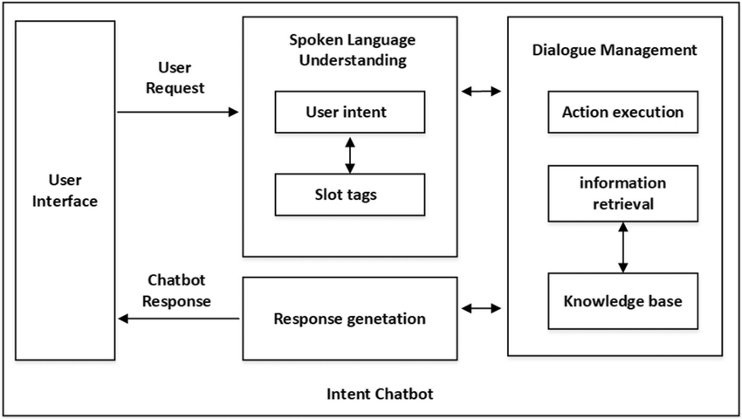

**Conclusion:**

Chatbots represent a practical application of AI that can automate real-world tasks, providing interactive and automated assistance to users. By leveraging NLP and structured dialogue management, chatbots can effectively serve various domains, enhancing user experience and operational efficiency.